- Starting from Grant Details (Grant Management>All Grants>Click on applicable Grant Name)
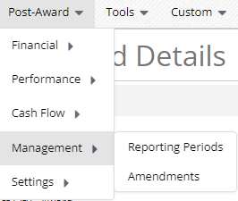
- Click on Post-Award>Management>Amendments


- Click on the plus icon in the upper right-hand corner

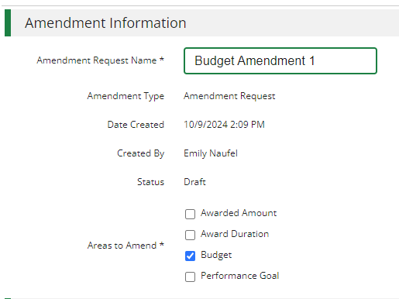
- Enter Amendment Request Name and check Budget under Areas to Amend

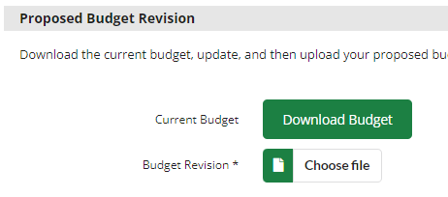
- Click Download Budget

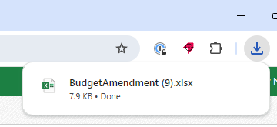
- Open the excel file (if using Chrome will display in the upper right-hand corner of your browser to open)

- Adjust the excel file leveraging the bulleted instructions below
- To add a line item include a Category, Line Item name, Line Item Type and Total Budgeted (Direct Cost) at a minimum (include match or other more granular budget details as required)
- To remove a line item delete the line item from the file
- To change total budgeted for a line item update the Total Budgeted (Direct Cost)
- To add, remove of change match update the Match Value columns
Important File Reminders:
- Do not change the column headers text
- Do not delete the columns identified with a *
- Actuals columns are for reference only and changing in the spreadsheet will not result in any changes in AmpliFund
- Grant Budgeted column is for reference only and changing in the spreadsheet will not result in any changes in AmpliFund
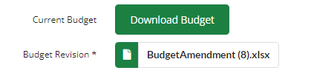
- Save the File
- Upload saved version of the file

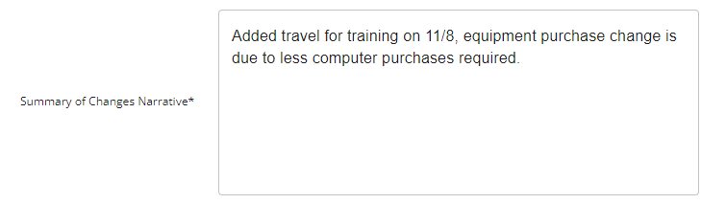
- Add Summary of Changes Narrative

- Review the Summary of Proposed Changes
If you need to make further edits, go back to the saved excel file, adjust as needed and re-upload excel file to the amendment.
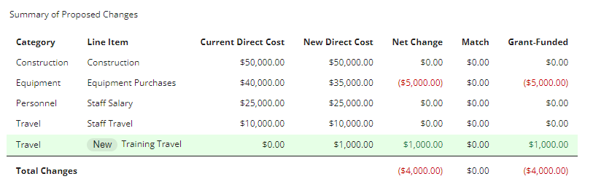
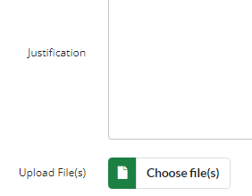
- Add Justification or Upload File(s) as/if required by your Funder

- Click Save to return and finish later or Submit to submit your finalized amendment to your funder

