Amplify Pre-Award Success
Use Research to identify new funding sources. Facilitate intent to apply using the Opportunity Review workflow. Streamline the submission process by creating a Pre-Award grant record and generate actionable insights using Pre-Award reports.

Identify New Funding Sources with Research Tool
- Explore funding opportunities by searching keywords and narrow down results selecting specific Program Categories, Funder types or Federal Departments
- Select a timeframe you’re looking to apply using the Submission Close Date After; and/or Before Filters
- Review search results and select an Opportunity to evaluate further
- Choose from two options:
  - Send to Opportunity Review
  - Convert to Pre-Award

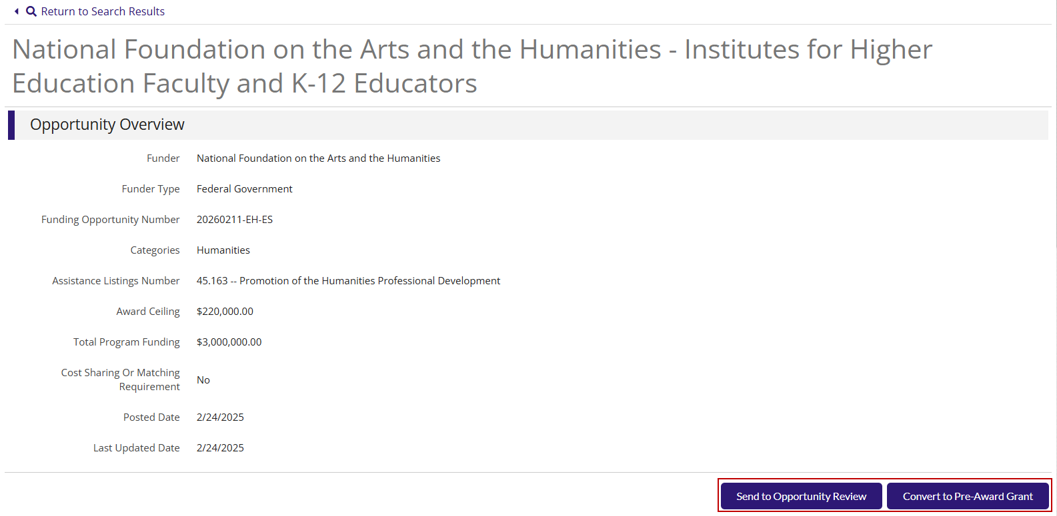

Send to Opportunity Review
- Select Send to Opportunity Review to share with other users to assess the opportunity. It will show under Research > Opportunity Review
Convert to Pre-Award
- Select Convert to Pre-Award Grant to create a Pre-Award Grant record.
- Enter Projected Receipt Date and Program Length and click Save
- Track key information under new Grant record such as Proposal Open and Close Date, Submitted Date, and Projected Receipt Date.

For full instructions on the Research tool, watch this video: Research Overview

Create a New Grant Award
Grant opportunities found outside of Euna Grants, powered by AmpliFund can be added to the system for full Pre-Award tracking:
- Identify the grant’s submission status, such as: Internal Review, To Be Submitted, Pending, Denied
- Set up budgets and performance plans, and add other Pre-Award information
- Store important files in Documents and other data in the Notes section
- Track critical application submission due dates and milestones using Tasks and Reminders
- Configure Pre-Award workflows to help you manage your application processes
- Collect final signatures using eSignature

To learn more about how to create a new Grant record, watch this Grants Overview Video.

Generate Pre-Award Reports
Pull All Your Data Together
- Run and view the Pre-Award Status Report under Reports
- Easily configure and filter data, including projected receipt date
- Customize formatting to draw attention to specific areas
- Get a glimpse of your grant status, dates, and amounts
- Build custom reports and dashboards to generate other insightful Pre-Award metrics
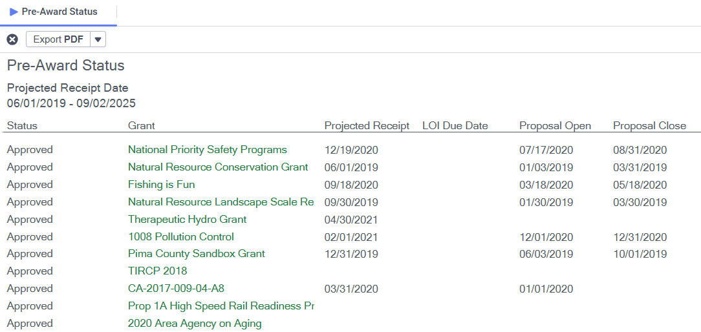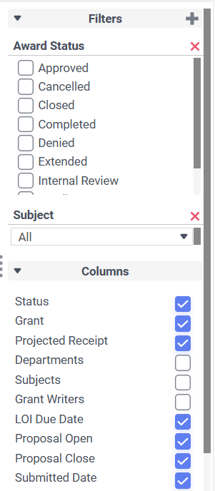

Hint: Optional Filters on the report provide more flexibility with the preferred data to show. Clickable boxes can increase and decrease number of columns.

