Improve Compliance with Deadlines ​
The Task feature and its automatic reminders can empower Grant Managers to ensure compliance with deadlines. Leveraging routine reminders for grants staff and recipients to submit their budget and performance reports, eliminates the need for funders to send multiple communications and provide internal transparency to grant managers. ​

How to Create Tasks
- Tools tab > Select Tasks > Click the Create icon in the upper right Icon Bar under Task Information.

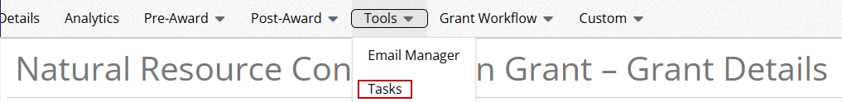

- Open an Object Record (e.g. Organizations, Grants, Funds, Projects, Individuals, Staff, Lead Recipients, and Sub-Recipients)

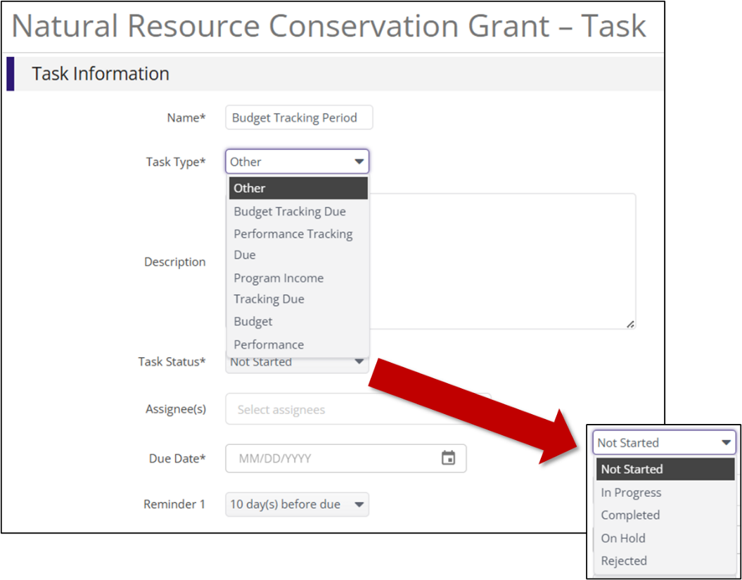
- Type in the Task Name ​
  - Hint: Consider using a naming convention suitable for your organization.​
- Select a Task Type from the drop-down menu​
  - Hint: This field provides more context and supports other reporting capabilities in the system. ​
- Use the optional Description box to add additional information.​
- Select the Task Status ​
  - Hint: If a new task is being created, keep the status as Not Started.
- Select one or more staff users as Assignees. They will receive email reminders and can view their task in Activity > Tasks or on the Calendar. ​
- Select a Due Date and set up optional Task Reminders
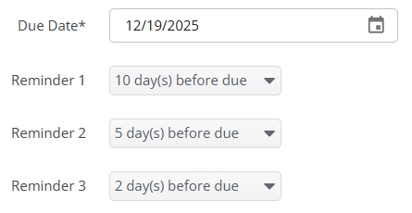
  - Hint: Task Reminders will send scheduled emails to the Assignee(s) to complete a task. You can select up to three separate reminders between 0 and 30 days before the task is due.​
- Click Save​

How to View and Create a Task
- Assignees can view their assigned Tasks and Statuses in two ways:​
  - Navigate to Activity > Tasks. The Task Grid will allow them to Edit the Task Status and Mark as Completed when they are finished.​

  - Log into Euna Grants, Powered by AmpliFund and click Activity > Calendar
​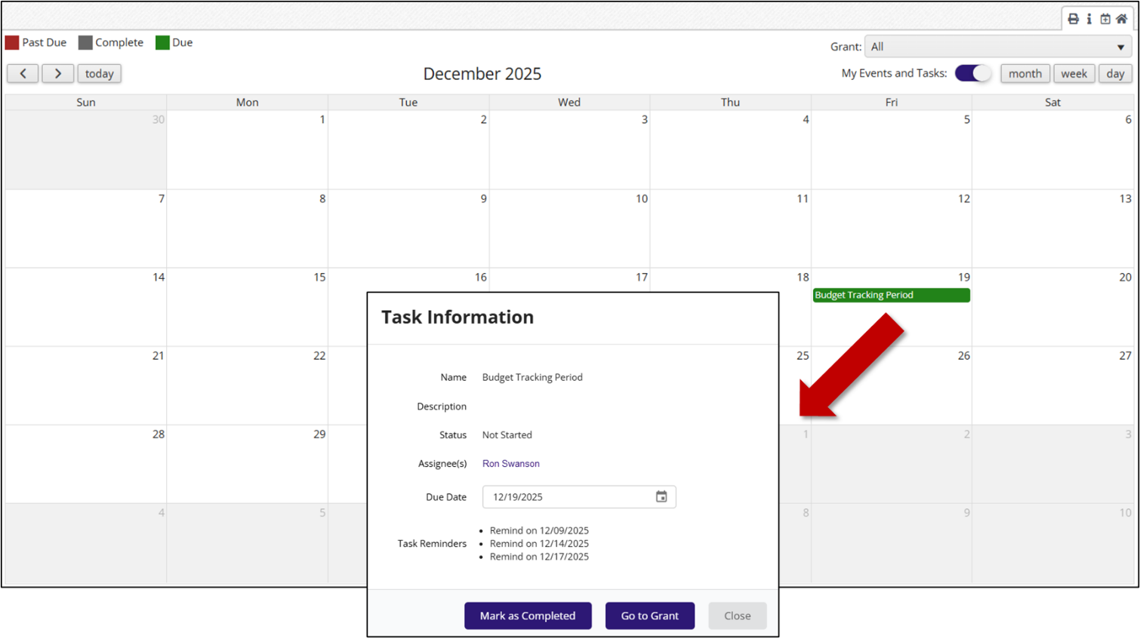

- The top left corner displays color-coded categories for any Past Due, Complete, or Due Tasks. ​
- By clicking on a Task, a pop-up with the Task’s information will appear
  - Hint: Tasks can view all Assignees’ tasks on the Task Grid or on the Calendar by toggling the green My Events and Tasks button to the left in the upper right corner
- Assignees can mark tasks Complete from the pop-up window. Users will not receive email reminders once the task is marked as Complete

For further assistance or Tasks reporting needs, reach out to your Customer Success Representative.

