Streamline Your Award Closeout ​
Build a robust and standardized Closeout process by leveraging a variety of tools in Euna Grants, powered by AmpliFund to ensure compliance has been met by the end of the funding period. It’s best practice to begin planning closeout midway through the Grant Lifecycle. Make sure your Closeout process adheres to your funder’s regulations or those within the 2 CFR-200 for Federal Grants.​ Design and manage your Closeout process using several of Euna Grants’ features described next:​​

Custom and Standard Reports
Euna Grants has a variety of standard and custom reports to support the financial reconciliation and programmatic reporting required for a successful closeout process. Custom reports’ data points and formatting can be configured and adapted to your needs. A good way to stay on top of your closeout requirements is by having any report be automatically delivered to your email on a regular basis. If you are interested to learn more or add a report to your account, please contact your Customer Success Representative.​

Closeout Custom Report ​
- Identifies grants within 90 days of their closeout date.​
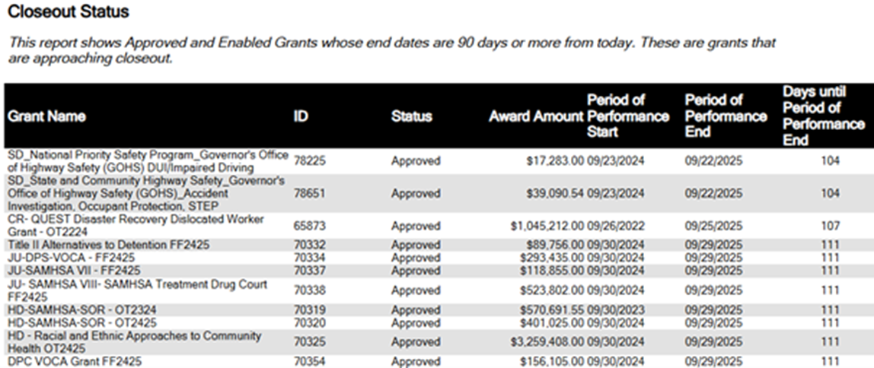

Grant Budget Variance Report ​
- Shows Budget vs Actuals at the category and line-item level by Grant​
- As you approach close-out stages, review this report periodically to monitor finding spend down is on track and before submitting the last invoice to your funder.​

Expense Detail Report​
- Lists all expenses broken down to the line-item level associated with an Award​
- Helps ensure financial reconciliation is aligned with the terms of the grant agreement

SF-425​
- Details financial status information to ensure accountability and transparency in the use of federal funds
- Tracks expenditures, obligations, and unobligated balances

Performance Plan Detail and/or Summary Report(s)
- Provides visibility into the tracking performance metrics associated with an Award
- Creates transparency with underperforming areas early allowing for timely corrective actions
- Identifies completion of all goals and achievements to support compliance

Workflow
As a grant approaches the closeout stage, enroll your Award in a Workflow to help guide grant managers and other users through the necessary steps to fulfill all closeout requirements. Use the Workflow feature to assign tasks to specific users and leverage email notifications to ensure timely completion.​

Custom Forms
Using Custom Forms linked to the Award record allows Grant Managers to maintain compliance by organizing and capturing additional data points in one centralized location.

These forms are highly configurable and flexible, allowing you to:
- Design a closeout checklist to identify tasks needing completion before closeout​
- Choose from a variety of field types such as single or multi-line text fields, multiple choice, dates, and attachments​

Some items your checklist may include: ​
- Identify outstanding financial obligations​
- Make decisions regarding property disposition​
- Prepare Programmatic and Financial reports​

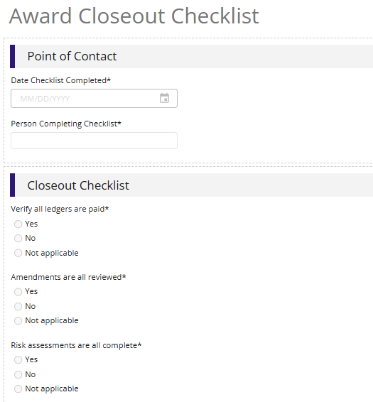
Documents
Even after the grant program period has ended, supporting documents, financials records, and other documents may be subject to future review. In a strong internal control environment, organizations will have written policies for retention of documents. Utilize Euna Grants‘ unlimited storage to: ​
- Store documentation from multiple sources in a centralized place to comply with retention policies​
- Choose from a variety of support file types and documents to be uploaded​
- Control documentation access by user role​
- Keep relevant financial records, evidence of program accomplishments, progress reports, final closeout letter, property disposition, and more​
- Ensure a funder’s retention requirements are met ​

Award Status
Change the Award Status to Closed to identify the grant entered the closeout period. This status will:​
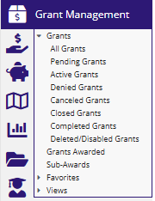
Recipients​
- Restrict from creating expenses, and submitting payment requests​
- Move the Grant Record from Active Grants sub-menu to Closed Grants within the Grant Management section.​
- Retain closed grants and related data to be referenced in the future​

Funder​
- Return unspent funds to the Unobligated Balance in the Fund, making unspent dollars available to be awarded out.​

Update the Award Status to Completed once the closeout period ends. ​

​For further assistance, reach out to your Customer Success Representative.

